Bridging Vision and Language in Construction: A Review of Automated Visual-to-Text Generation
Negin Mahmoudi¹, Maedeh Haghbin Yousefi², Mohammad Ilbeigi^{3*}, Abdolmajid Erfani⁴, and Abbas Rashidi⁵
¹ Ph.D. Student, Dept. of Civil, Environmental, and Ocean Engineering, Stevens Institute of Technology, Hoboken, NJ 07030. nmahmoud1@stevens.edu
² Ph.D. Student, Department of Civil and Environmental Engineering, The University of Utah, Salt Lake City, UT, 84112. maedeh.yousefi@utah.edu
³ Assistant Professor, Dept. of Civil, Environmental, and Ocean Engineering, Stevens Institute of Technology, Hoboken, NJ, USA, 07030, milbeigi@stevens.edu (corresponding author)
⁴ Assistant Professor, Dept. of Civil, Environmental, and Geospatial Engineering, Michigan Technological University, Houghton, MI, USA, 49931, aerfani@mtu.edu
5 Associate Professor, Department of Civil and Environmental Engineering, The University of Utah, Salt Lake City, UT, 84112. abbas.rashidi@utah.edu

Table S1. Construction problems addressed by visual-to-text generation
Problem | Problem-Specific Task | Studies
Safety management | Hazard Identification and Risk Assessment | Wang et al. (2022), Zhai et al. (2023), Hsiao et al. (2024), Kim et al. (2024), Wang et al. (2024b), Zhu et al. (2024), Chen & Yin (2025), Guo et al. (2025), Guo et al. (2026), Sivanraj et al. (2026)
 | Detection of Unsafe Behaviors and Non-Compliant Actions | Ding et al. (2022), Gil & Lee (2024), Abidi et al. (2025), Chan et al. (2025), Kim et al. (2025), Hussain et al. (2026), Wang et al. (2026), Xu et al. (2026)
 | Ergonomic Risk Assessment | Fan et al. (2024), Yong et al. (2024a), Yong et al. (2024b), Yong et al. (2024c)
 | Scene-Level Safety Understanding | Chen et al. (2023a), Zhong et al. (2023)
 | Safety-Inspection Reporting | Tsai et al. (2023), Chen et al. (2024), Tsai et al. (2025)
Progress monitoring | Resource & Location-Based Progress Tracking | Bang & Kim (2020)
 | work activity log | Xiao et al. (2024)
Scene documentation | Construction Activity Documentation | Liu et al. (2020), Ding & Luo (2021), Xiao et al. (2022), Song et al. (2024), Deng et al. (2025) ; Jung et al. (2024),
 | Infrastructure Inspection Documentation | Pu et al. (2024a), Pu et al. (2024b), Chang et al. (2024), Bazrafshan et al. (2025)
 | Scene-level environment understanding | Chen et al. (2023b), Wang et al. (2024a), Sree et al. (2025)
Damage & condition assessment | Disaster damage assessment | Aydin et al. (2026)
 | Structural distress / defect inspection | Dinh et al. Ahn (2024); Watanabe et al. (2024)

Table S2. Visual data acquisition platforms used in the reviewed studies
Note: If a study incorporates more than one acquisition platform, it is assigned to all relevant categories.
Main category | Acquisition Platform | Studies
Aerial-level | UAV / drone | Bang & Kim (2020); Xiao et al. (2022); Abidi et al. (2025); Aydin et al. (2026); Xu et al. (2026).
 | Satellite imagery | Chen et al. (2023b); Wang et al. (2024a); Sree et al. (2025).
Ground-level | Fixed cameras  (CCTV / surveillance) | Xiao et al. (2022); Zhong et al. (2023); Chen et al. (2024); Hsiao et al. (2024); Xiao et al. (2024); Chan et al. (2025); Chen & Yin (2025); Sivanraj et al. (2026).
 | Manual photos  (inspector-taken / mobile or camera) | Liu et al. (2020); Ding & Luo (2021); Wang et al. (2022); Chen et al. (2023a); Tsai et al. (2023); Zhai et al. (2023); Chang et al. (2024); Dinh et al. Ahn (2024); Gil & Lee (2024); Jung et al. (2024); Kim et al. (2024); Pu et al. (2024b); Song et al. (2024); Wang et al. (2024b); Watanabe et al. (2024); Zhu et al. (2024); Bazrafshan et al. (2025); Chen & Yin (2025); Deng et al. (2025); Guo et al. (2025); Kim et al. (2025); Tsai et al. (2025); Guo et al. (2026); Hussain et al. (2026).
 | Wearables  (AR helmets/body cams) | Chen et al. (2024)
 | Robotic platforms  (UGV / quadruped robots) | Pu et al. (2024a); Abidi et al. (2025)
 | Web-based (internet-crawled / YouTube / istock) | Ding & Luo (2021); Ding et al. (2022); Xiao et al. (2022); Zhong et al. (2023); Zhai et al. (2023); Fan et al. (2024); Yong et al. (2024a); Yong et al. (2024b); Yong et al. (2024c); Abidi et al. (2025); Bazrafshan et al. (2025); Chan et al. (2025); Chen & Yin (2025); Deng et al. (2025); Guo et al. (2025); Hussain et al. (2026); Wang et al. (2026); Xu et al. (2026).
 | Synthetic images | Xu et al. (2026)

Table S3. Annotation classes across datasets
Note: Reported only if specified by the source.
Dataset | Classes
MOCS  (An et al., 2021) | 13 construction object classes  Worker; Tower crane; Hanging hook; Vehicle crane; Roller; Bulldozer; Excavator; Truck; Loader; Pump truck; Concrete mixer truck; Pile driver; Other vehicle
ACID  (Xiao & Kang, 2021) | 10 construction machine classes  Excavator; Compactor; Bulldozer; Grader; Dump truck; Concrete mixer truck; Wheel loader; Backhoe loader; Tower crane; Mobile crane
SODA  (Duan et al., 2022) | 16 construction operation scene categories  Tower crane lifting; Truck crane lifting; Crawler crane lifting; Gantry crane lifting; Hoisting steel components; Hoisting prefabricated components; Hoisting building materials; Equipment installation lifting; Structural assembly lifting; Material transportation lifting; Multi-worker cooperative lifting; Ground guiding operations; Suspended load positioning; Load binding operations; Site lifting preparation; General lifting workflow scenes
Construction Scene Graph Dataset  (Zhang et al., 2022) | 9 construction object categories:  Worker; Hardhat; Brick; Welder; Facial mask; Glove; Scaffold; Vest; Excavator  7 interaction types:  Drive; Under; Lay; Stand on; Operate; Wear; Next to
CPPED  (Chen et al., 2025) | 13 PPE-related object classes:  person; head; safety vest; safety glasses; mask; gloves; no-gloves; shoes; no-shoes; safety helmet (white, blue, red, yellow)
Harvard Dataverse Hardhat Dataset  (Xie, 2019) | Hardhat presence/absence  No additional information is specified.
Ladder dataset  (Anjum et al., 2022) | 5 ladder safety classes:  Ladder with outriggers; Ladder without outriggers; Worker with helmet; Worker without helmet; Worker with safety belt
Mobile scaffold dataset  (Khan et al., 2021) | 3 construction safety classes:  Person; Mobile scaffold with outriggers (safescaffold); Mobile scaffold without outriggers (scaffold)
iSafe Welding System dataset  (Zaidi et al., 2023) | 5 welding safety classes:  Welding equipment; Worker with PPE; Welding machine; Fire extinguisher; Flammable material
FloodNet  (Rahnemoonfar et al., 2021) | 9 semantic classes:  building-flooded; building-non-flooded; road-flooded; road-non-flooded; water; tree; vehicle; pool; grass
LADI-v2  (Scheele et al., 2024) | 12 damage and infrastructure classes:  Bridges_any; Buildings_any; Buildings_affected_or_greater; Buildings_minor_or_greater; Debris_any; Flooding_any; Flooding_structures; Roads_any; Roads_damage; Trees_any; Trees_damage; Water_any

Table S4. Model architecture of reviewed studies
Model Architecture | Core Backbone | Studies
Classical Encoder-Decoder | CNN + LSTM | Bang & Kim (2020); Liu et al. (2020); Wang et al. (2022); Chen et al. (2023b); Zhai et al. (2023); Zhong et al. (2023); Dinh et al. Ahn (2024); Zhu et al. (2024); Wang et al. (2024b); Sree et al. (2025); Deng et al. (2025); Wang et al. (2026)
 | CNN + Transformer | Xiao et al. (2022); Chen et al. (2023a)
 | CNN + GRU | Hsiao et al. (2024)
 | Swin Transformer + Transformer | Song et al. (2024)
Hybrid Models | CLIP + GPT-2 | Tsai et al. (2023); Gil & Lee (2024); Tsai et al. (2025);  Guo et al. (2026)
 | CLIP + LLaMA | Wang et al. (2024a)
 | CNN + GPT-3.5 | Xiao et al. (2024)
 | CNN + GPT-4 | Hussain et al. (2026)
Vision-Language Pretrained Models | UNIMO | Ding & Luo (2021)
 | ViLT | Ding et al. (2022)
 | OTTER | Watanabe et al. (2024)
 | InstructBLIP | Yong et al. (2024c)
 | mPLUG | Jung et al. (2024)
 | BLIP + BART | Yong et al. (2024b)
 | BLIP | Chen et al. (2024)
 | BLIP-2 | Abidi et al. (2025); Aydin et al. (2026)
 | Florence-2 | Sivanraj et al. (2026)
Large Multi-Modal Models | MiniGPT-4 | Pu et al. (2024a); Chang et al. (2024); Pu et al. (2024b);  Yong et al. (2024a)
 | LLaVA | Kim et al. (2024)
 | GPT-4V | Fan et al. (2024); Kim et al. (2025); Bazrafshan et al. (2025)
 | CogVLM-17B | Chan et al. (2025)
 | InternVL-2 Pro | Guo et al. (2025)
 | Qwen2-VL-7B | Chen & Yin (2025)
 | Qwen2.5-VL-7B | Xu et al. (2026)
Table S5. Evaluation metrics for construction visual-to-text generation
Metric | Equation
BLEU | $$BLEU=exp\left(\sum_{n=1}^{N}{w_{n}}\log{p_{n}}\right).min\left(1,e^{1-r/c}\right)$$
ROUGE | $$\text{ROUGE-L}=\frac{(1+β^{2})R_{LCS}⋅P_{LCS}}{R_{LCS}+β^{2}⋅P_{LCS}}$$
 | $$\text{ROUGE-}\text{N}=\frac{(1+β^{2})R_{N}⋅P_{N}}{R_{N}+β^{2}⋅P_{N}}$$
METEOR | $$\text{METEOR}=(1-\text{Pen})⋅F_{\text{mean}}$$  $$F_{mean}=\frac{P.R}{α.P+(1-α).R}$$
CIDEr | $$\text{CIDEr}(C_{i},S_{i})=\sum_{n=1}^{N}{ω_{n} {\text{CIDEr}}_{n}(C_{i},S_{i})}$$
 | $${\text{CIDEr}}_{n}(C_{i},S_{i})=\frac{1}{m}\sum_{j}{cos(C_{i},s_{ij})}$$
BERSTScore | $${\text{F}}_{\text{BERT}}=2⋅\frac{{\text{P}}_{\text{BERT}}⋅{\text{R}}_{\text{BERT}}}{{\text{P}}_{\text{BERT}}+{\text{R}}_{\text{BERT}}}$$
 | $${\text{R}}_{\text{BERT}}=\frac{1}{\text{∣}S\text{∣}}\sum_{j∈S}{\underset{i∈C}{max⁡}cos⁡(S_{j},C_{i})}$$
 | $${\text{P}}_{\text{BERT}}=\frac{1}{\text{∣}C\text{∣}}\sum_{i∈C}{\underset{j∈S}{max⁡}cos⁡(S_{i},C_{j})}$$
WMD | $$\text{WMD}(S,C)=\underset{T≥0}{min⁡}\sum_{i,j=1}{T_{ij} . ∆(.,.)}$$
 | $$\sum_{j}{T_{ij}}=d_{i}, \sum_{i}{T_{ij}}={d'}_{j}$$
Cosine sim | $$\text{cos}(C,S)=\frac{C⋅S}{\text{∥}C\text{∥∥}S\text{∥}}$$
SPICE | $$\text{SPICE}=\frac{2⋅P(C,S)⋅R(C,S)}{P(C,S)+R(C,S)}$$
Keyword recall | $$\text{Keyword Recall}\text{(C,S)}=\frac{\text{∣}K(S)⋂K(C)\text{∣}}{\text{∣}K(C)\text{∣}}$$
CLIPScore | $$\text{CLIPScore}=W.max(cos(C,V),0)$$
Recall@K | $$\text{Recall@K}=\frac{\left|\left\{q∈Q: S_{q}∈top-K(q)\right\}\right|}{\left|Q\right|}$$
IoU | $$\text{IoU}=\frac{TP}{\text{TP+FN+FP}}$$
AP | $$\text{AP}=\sum_{k}{P(k).∆R(k)}$$
mAP | $$\text{mAP}=\frac{1}{C}\sum_{ς∈C}{{\text{AP}}_{ς}}$$
Accuracy | $$\text{Accuracy}=\frac{TP+TN}{TP+TN+FP+FN}$$
Precision | $$\text{Precision}=\frac{TP}{TP+FP}$$
Recall | $$\text{Recall}=\frac{TP}{TP+FN}$$
F1-score | $$\text{F1}=\frac{2⋅\text{Precision}⋅\text{Recall}}{\text{Precision}+\text{Recall}}$$
F2-score | $$\text{F2}=\frac{(1+2^{2})⋅\text{Precision}⋅\text{Recall}}{2^{2}⋅\text{Precision}+\text{Recall}}$$
Table S6. Notation of evaluation metrics
Variable | Definition
${\text{AP}}_{ς}$ | Average Precision for category $ς$
${\text{CIDEr}}_{n}(c_{i},S_{i})$ | Average cosine similarity between candidate and reference
$f_{i}$ | Normalized frequency of word i in candidates C
${f'}_{j}$ | Normalized frequency of word j in references S
$P_{LCS}$ | Precision based on the longest common subsequence
$p_{n}$ | Modified n-gram precision for order n
$P_{N}$ | n-gram recall - fraction of reference n-grams matched in candidate C
$R_{LCS}$ | Recall based on the longest common subsequence
$R_{N}$ | n-gram precision - fraction of candidate n-grams matched in reference S
$S_{q}$ | Correct candidate for query q
$T_{ij}$ | Transport flow from word i in candidate C to word j in reference S
$w_{n}$ | Weight for n-grams
$ω_{n}$ | Uniform weight per n-gram order
$∆(.,.)$ | Euclidean distance
c | Candidate length
$C$ | Set of candidate token embeddings
$C,S$ | Candidate and reference document
$cos(.,.)$ | Cosine similarity between two token embeddings
F_{mean} | Harmonic mean
FN | False negative
FP | False positive
K | Number of top retrieved results considered
$K(C)$ | Set of domain-specific keywords found in candidate C
$K(S)$ | Set of all relevant domain-specific keywords in reference S
N | n-gram order
n | n-gram order
P | Precision
$P(C,S)$ | Precision of candidate C and reference S
$P(k)$ | Precision at threshold k
Pen | Fragmentation penalty
q | A single query
Q | Set of all queries
r | Reference length
R | Recall
$R(C,S)$ | Recall of candidate C and reference S
$R(k)$ | Change in recall at threshold k
$S$ | Set of reference token embeddings
TN | True negative
$top-K(q)$ | Set of top K retrieved candidates for query q
TP | True positive
V | Clip the visual embedding of the input image
α | Weight factor in the harmonic mean
$Β$ | Recall/precision balance weight
$C$ | Set of all object categories
$ς$ | A single object category
$ς$ | A single object category

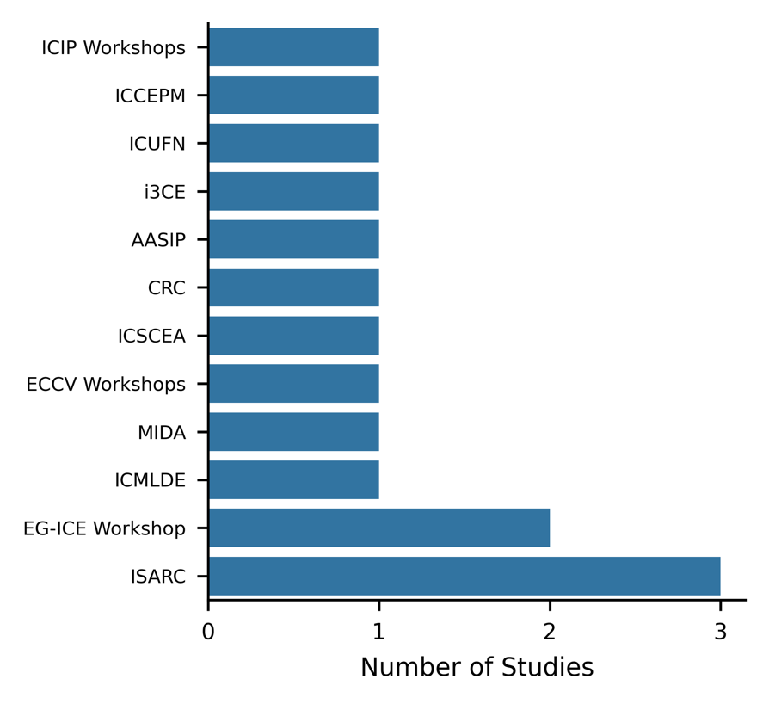
Fig. S1. Distribution of Identified Studies Across Conference Venues
Abbreviations:
ICIP = IEEE International Conference on Image Processing
ICCEPM = International Conference on Construction Engineering and Project Management
ICUFN = International Conference on Ubiquitous and Future Networks
i3CE = ASCE International Conference on Computing in Civil Engineering
AASIP = International Conference on Advanced Algorithms and Signal Image Processing
CRC = Construction Research Congress
ICSCEA = International Conference on Sustainable Civil Engineering and Architecture
ECCV = European Conference on Computer Vision
MIDA = International Conference on Machine Intelligence and Digital Applications
ICMLDE = International Conference on Machine Learning and Data Engineering
EG-ICE = European Group for Intelligent Computing in Engineering
ISARC = International Symposium on Automation and Robotics in Construction

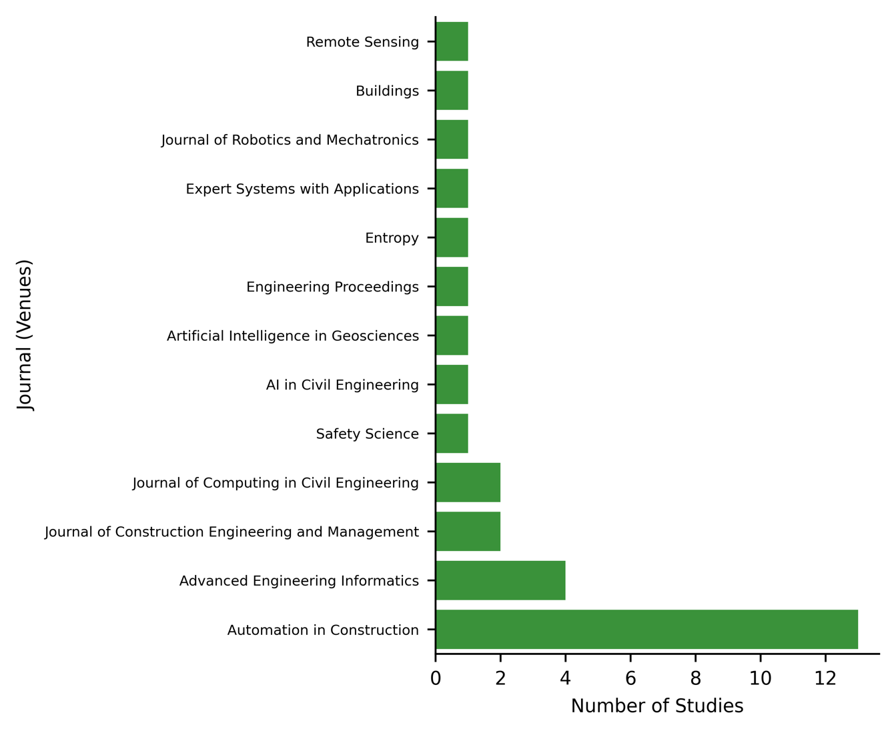
Fig. S2. Distribution of identified studies across journal venues
Publishers and their journals: Elsevier (Automation in Construction, Advanced Engineering Informatics, Expert Systems with Applications, Artificial Intelligence in Geosciences, Safety Science); ASCE (Journal of Construction Engineering and Management, Journal of Computing in Civil Engineering); MDPI (Buildings, Entropy, Engineering Proceedings, Remote Sensing); Springer (AI in Civil Engineering); Fuji Technology Press (Journal of Robotics and Mechatronics).

